Assignment 2 | MSDS 420 | Kagen Quiballo | 10/13/2021

Use the SaleCo ERD listed below and the provided SQL scripts to construct its relational database and answer the following queries.

Note: Purchases = LINE_PRICE * LINE_UNITS

Note: Inventory value = P_QOH * P_PRICE

1. **(2 pts)** How many invoices are there?

SELECT COUNT(*) FROM INVOICE; Answer: 8

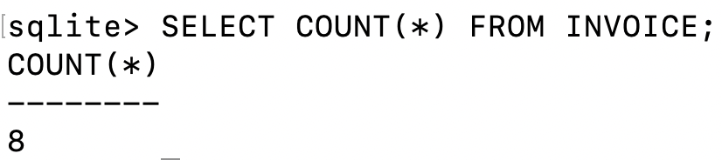

**(3 pts)** List the invoice numbers and the invoice dates.

SELECT INV_NUMBER, INV_DATE FROM INVOICE;

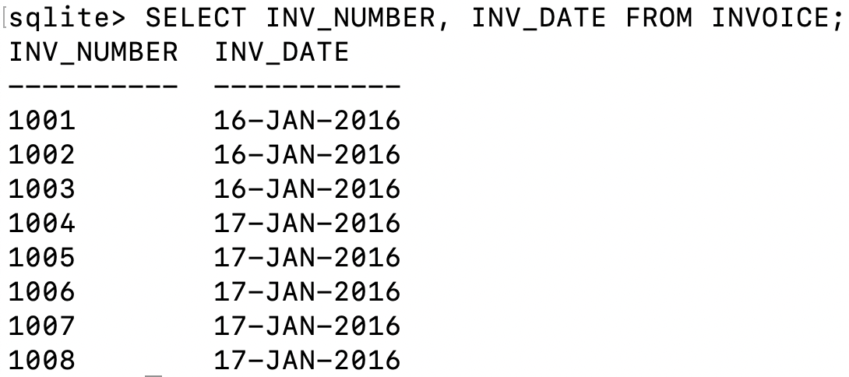

1. **(2 pts)** How many customers are there?

SELECT COUNT(*) FROM CUSTOMER; Answer: 10

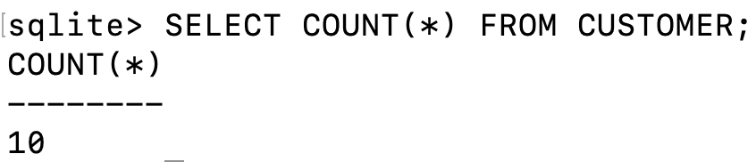

**(3 pts)** List the customer codes and customer names.

SELECT CUS_CODE, CUS_FNAME, CUS_LNAME FROM CUSTOMER;

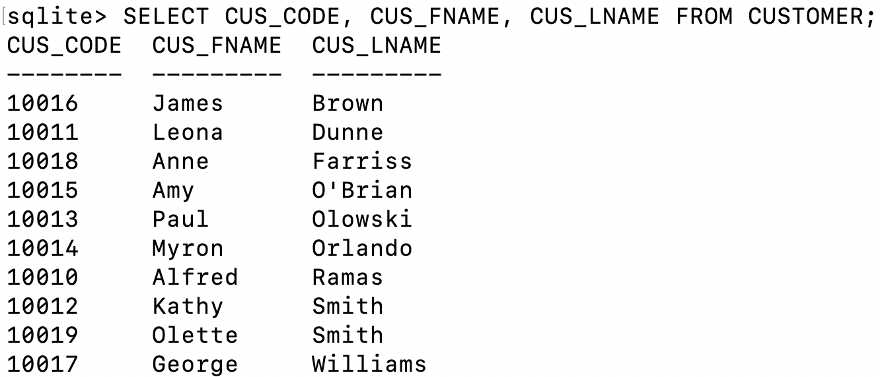

1. **(2 pts)** List vendor numbers and vendor names.

SELECT V_CODE, V_NAME FROM VENDOR;

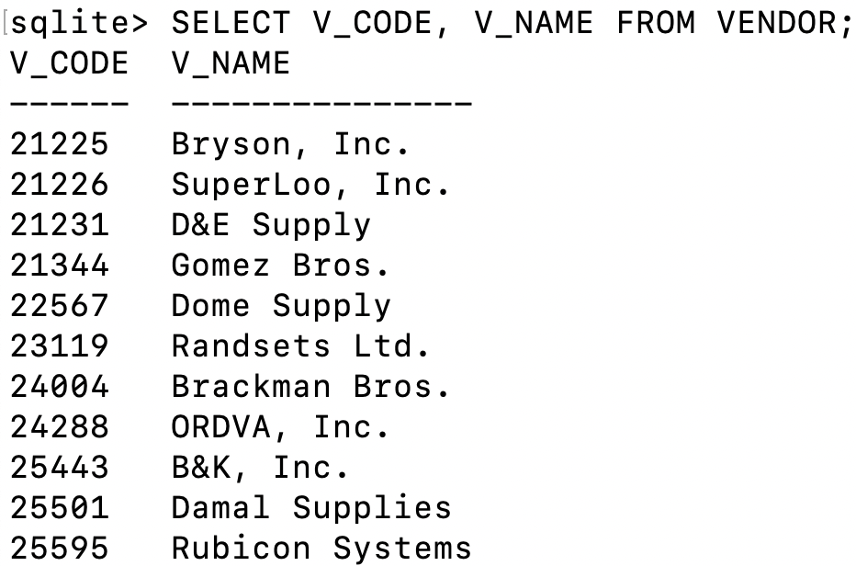

**(3 pts)** Show the vendor count per state.

SELECT V_STATE, COUNT(*) FROM VENDOR GROUP BY V_STATE;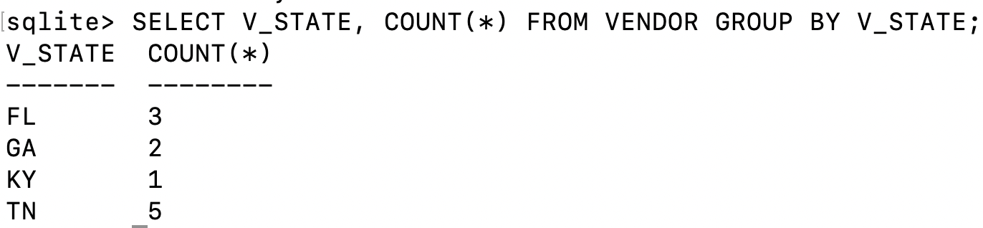

1. **(2 pts)** Based on price, what is the most expensive product?

SELECT P_CODE, P_DESCRIPT, P_PRICE FROM PRODUCT ORDER BY P_PRICE DESC; Answer: 89-WRE-Q, Hicut chain saw, 16 in. 256.99

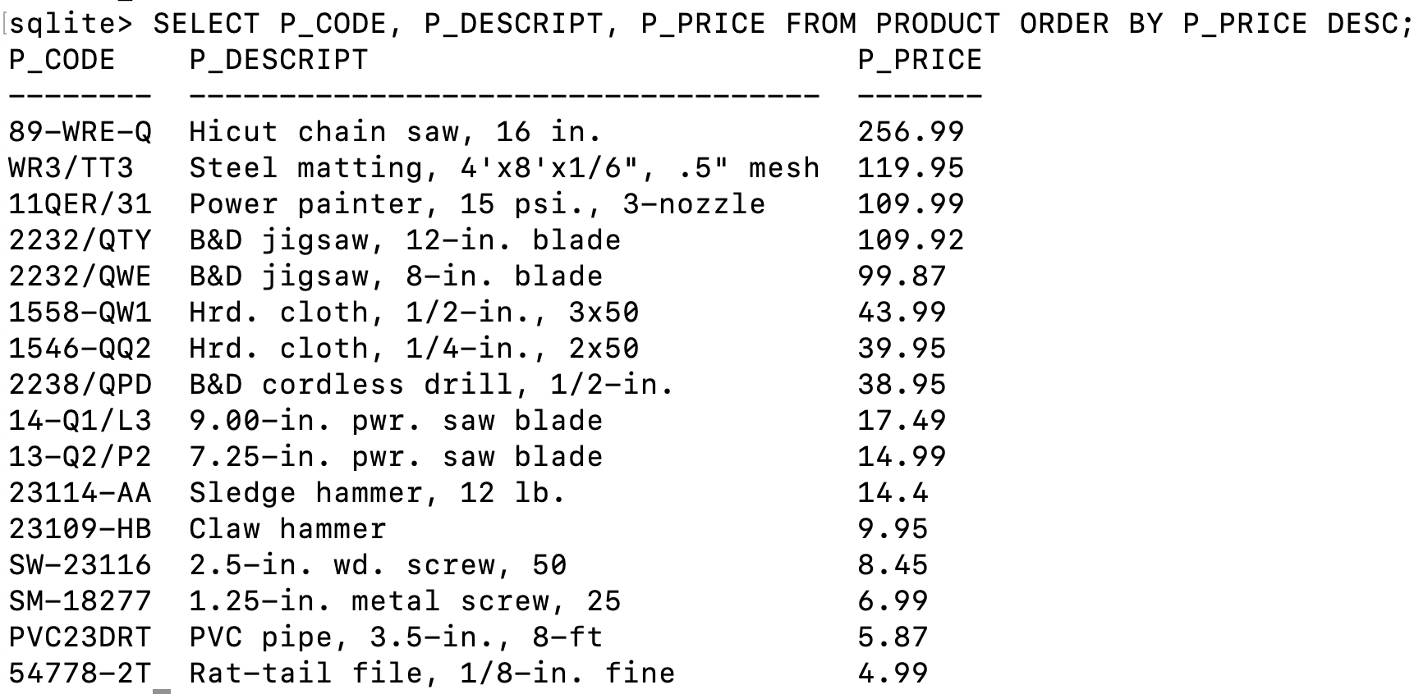

**(3 pts)** How much quantity on hand is available for the most expensive product?

SELECT P_CODE, P_DESCRIPT, P_QOH FROM PRODUCT WHERE P_CODE=’89-WRE-Q’; Answer: 11

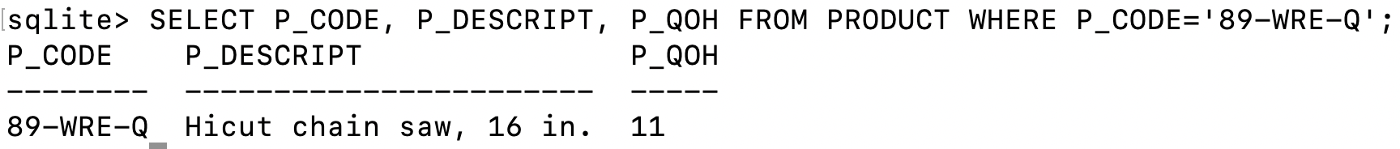

1. **(2 pts)** Write a query to count the number of customers with a customer balance over $500.

SELECT COUNT(*) FROM CUSTOMER WHERE CUS_BALANCE>500;

Answer: 2

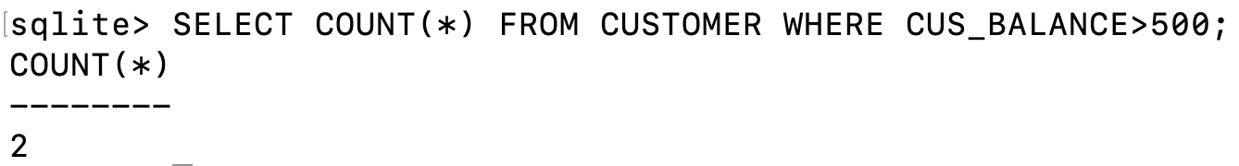

**(3 pts)** List the customer code, customer name and balance amount of these customers.

SELECT CUS_CODE, CUS_FNAME, CUS_LNAME, CUS_BALANCE FROM CUSTOMER WHERE CUS_BALANCE>500;

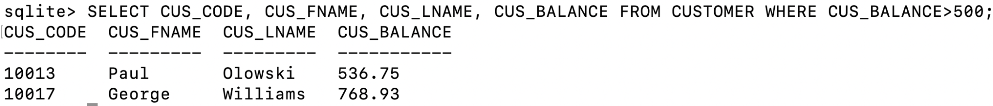

1. **(7 pts)** Generate a listing of products offered by each Vendor. List vendor name, product code and product name. Sort by vendor name and product code.

SELECT V.V_NAME, P.P_CODE, P.P_DESCRIPT

FROM PRODUCT AS P

INNER JOIN VENDOR AS V

ON V.V_CODE =P.V_CODE

ORDER BY V.V_NAME, P.P_CODE;

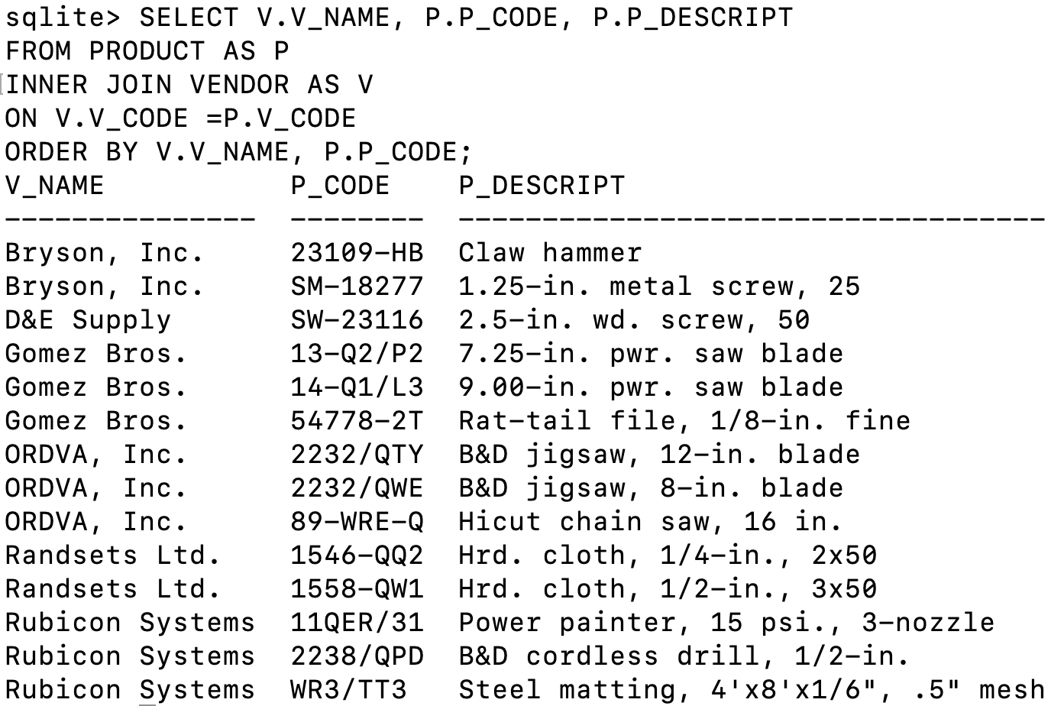

1. **(7 pts)** Generate a listing of customer purchases, including the subtotals for each of the invoice line numbers; sort output by customer code, invoice number and the line_number.

SELECT SUM(LINE_PRICE * LINE_UNITS), I.CUS_CODE, I.INV_NUMBER, L.LINE_NUMBER

FROM LINE AS L

LEFT JOIN INVOICE AS I

ON I.INV_NUMBER =L.INV_NUMBER

GROUP BY I.INV_NUMBER, L.LINE_NUMBER

ORDER BY I.CUS_CODE, I.INV_NUMBER, L.LINE_NUMBER;

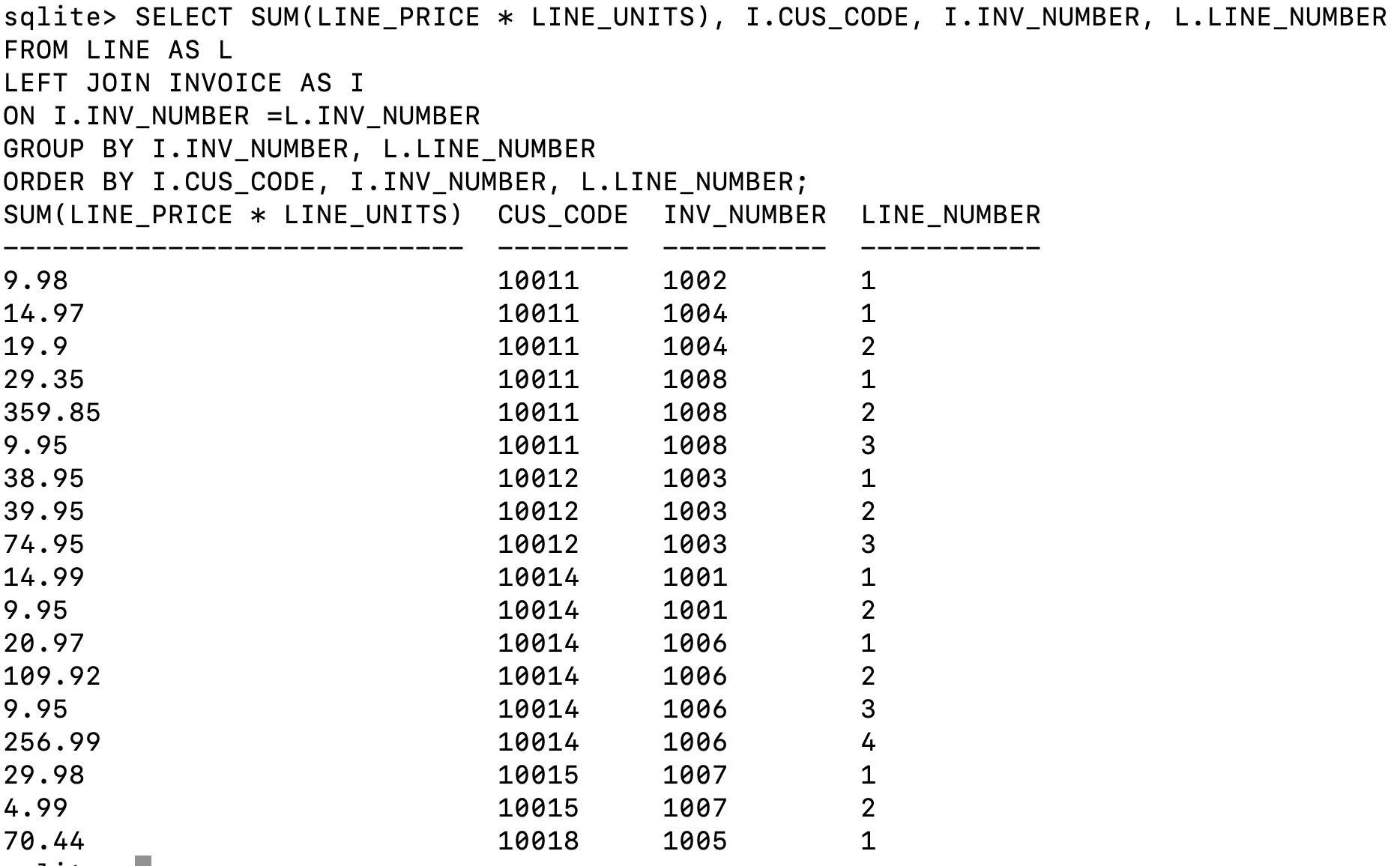

1. **(7 pts)** List the balance characteristics of the customers who have made purchases during the current invoice cycle—that is, for the customers who appear in the INVOICE table; sort by customer code.

SELECT CUS_CODE, CUS_BALANCE

FROM CUSTOMER

WHERE CUS_CODE IN (SELECT CUS_CODE FROM INVOICE)

ORDER BY CUS_CODE;

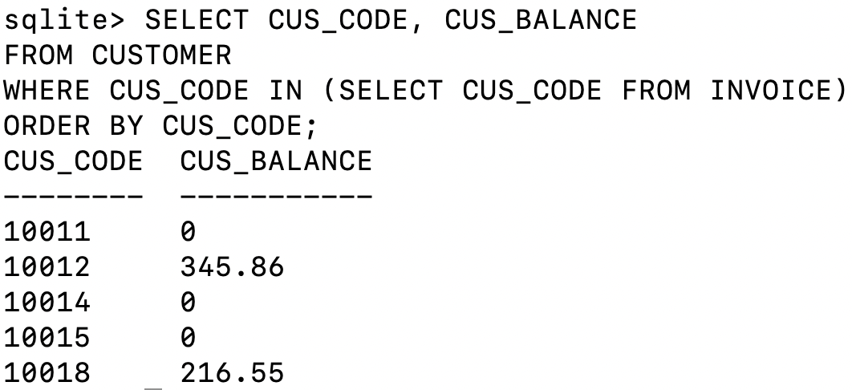

1. **(7 pts)** Find a listing of customers who did not make purchases during the invoicing period; sort by customer code.

SELECT CUS_CODE

FROM CUSTOMER

WHERE CUS_CODE NOT IN (SELECT CUS_CODE FROM INVOICE)

ORDER BY CUS_CODE;

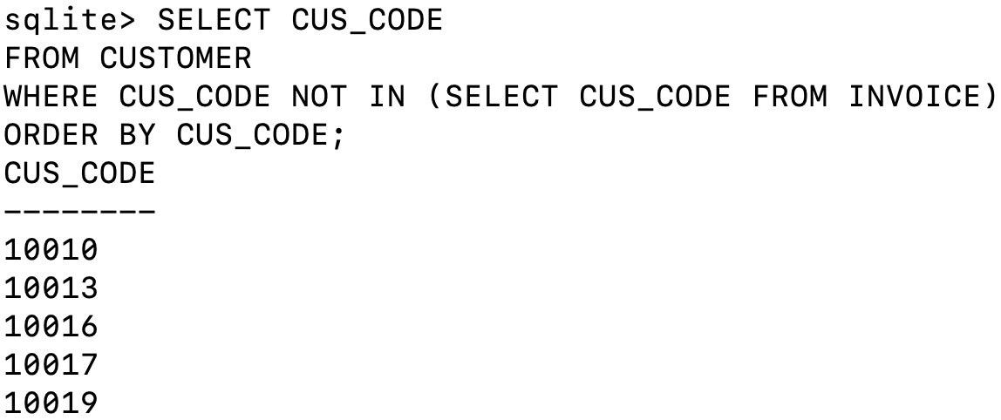

1. **(7 pts)** Create a query to produce a summary of the value of products currently in inventory.

SELECT P_CODE, P_DESCRIPT, P_QOH, P_PRICE, P_QOH * P_PRICE AS VALUE

FROM PRODUCT

ORDER BY P_CODE;

